TASK 17:

* Install FTP server on the Virtual Machine
* Create a Logic app
* Trigger an Email notification.
* For each update happening in FTP server.

Steps:

Step 1: Create virtual machine with name ‘vm1’

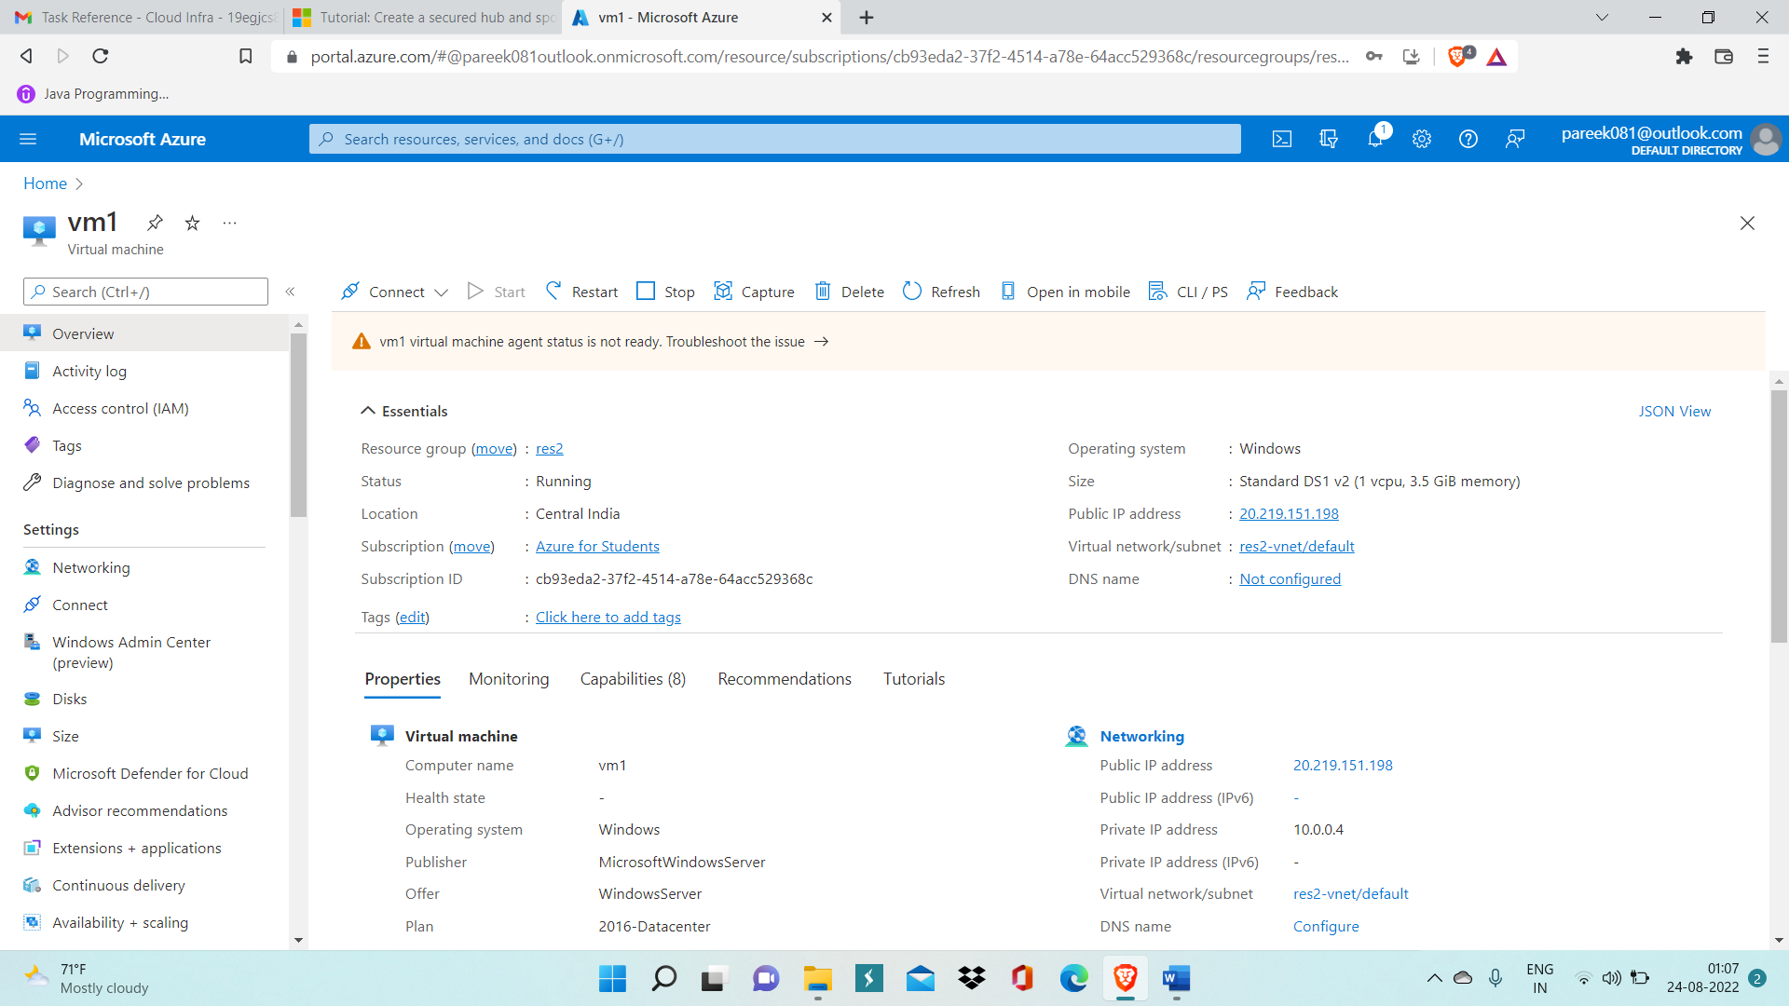

Step 2: Now connect to virtual machine and Open Add roles and Features wizard.

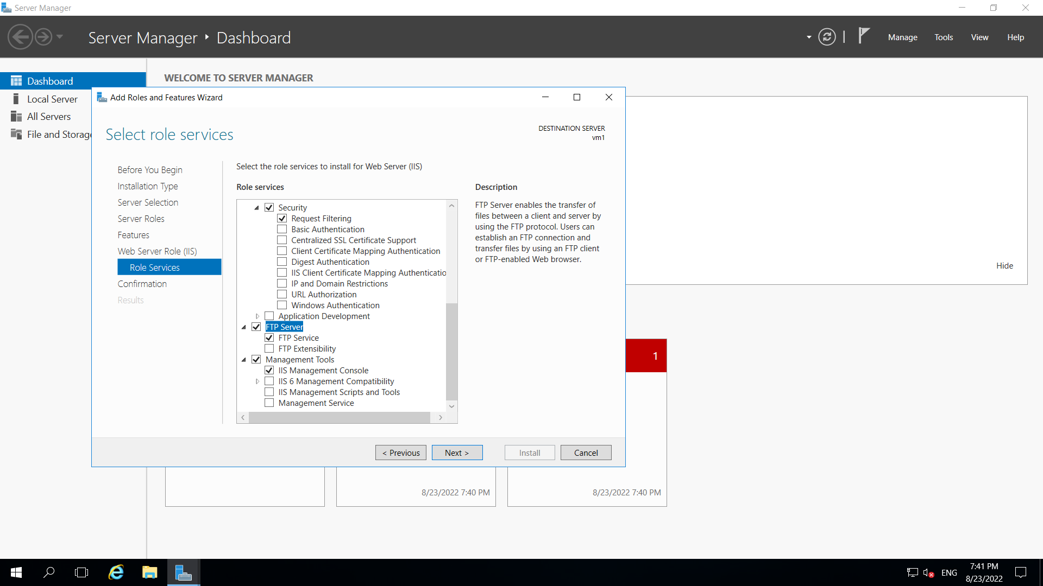

Step 3: Inside this wizard click FTP server and then install it.

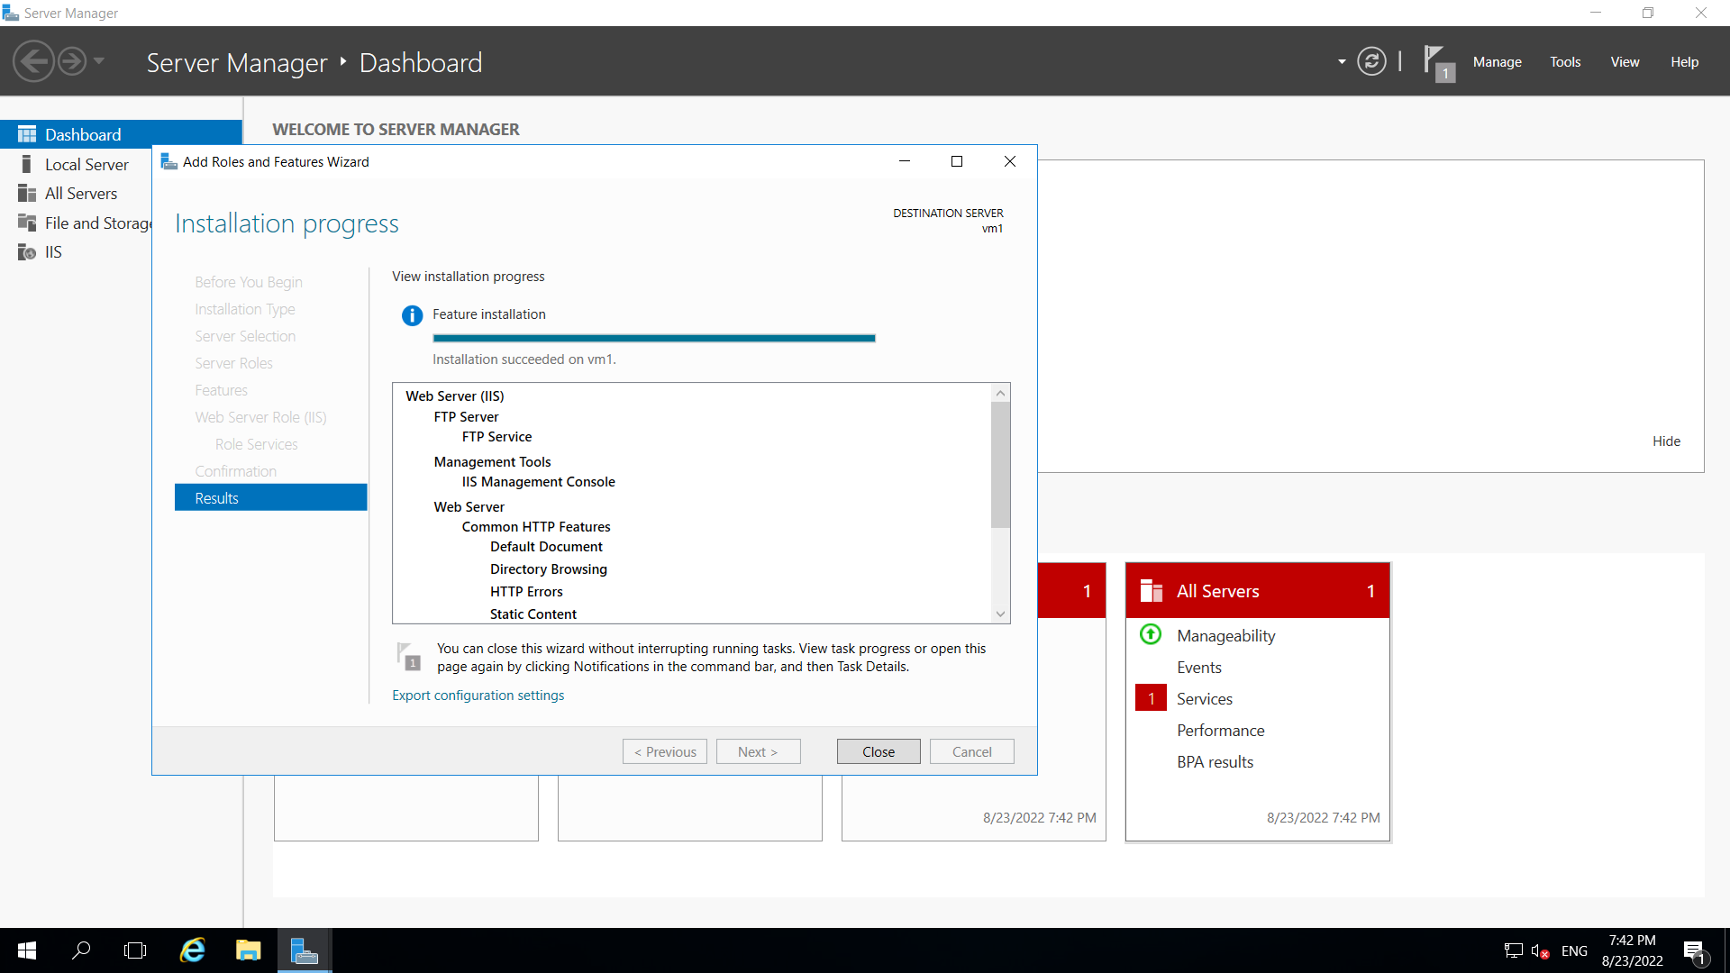

Step 4: GO inside IIS manager and create New FTP site.

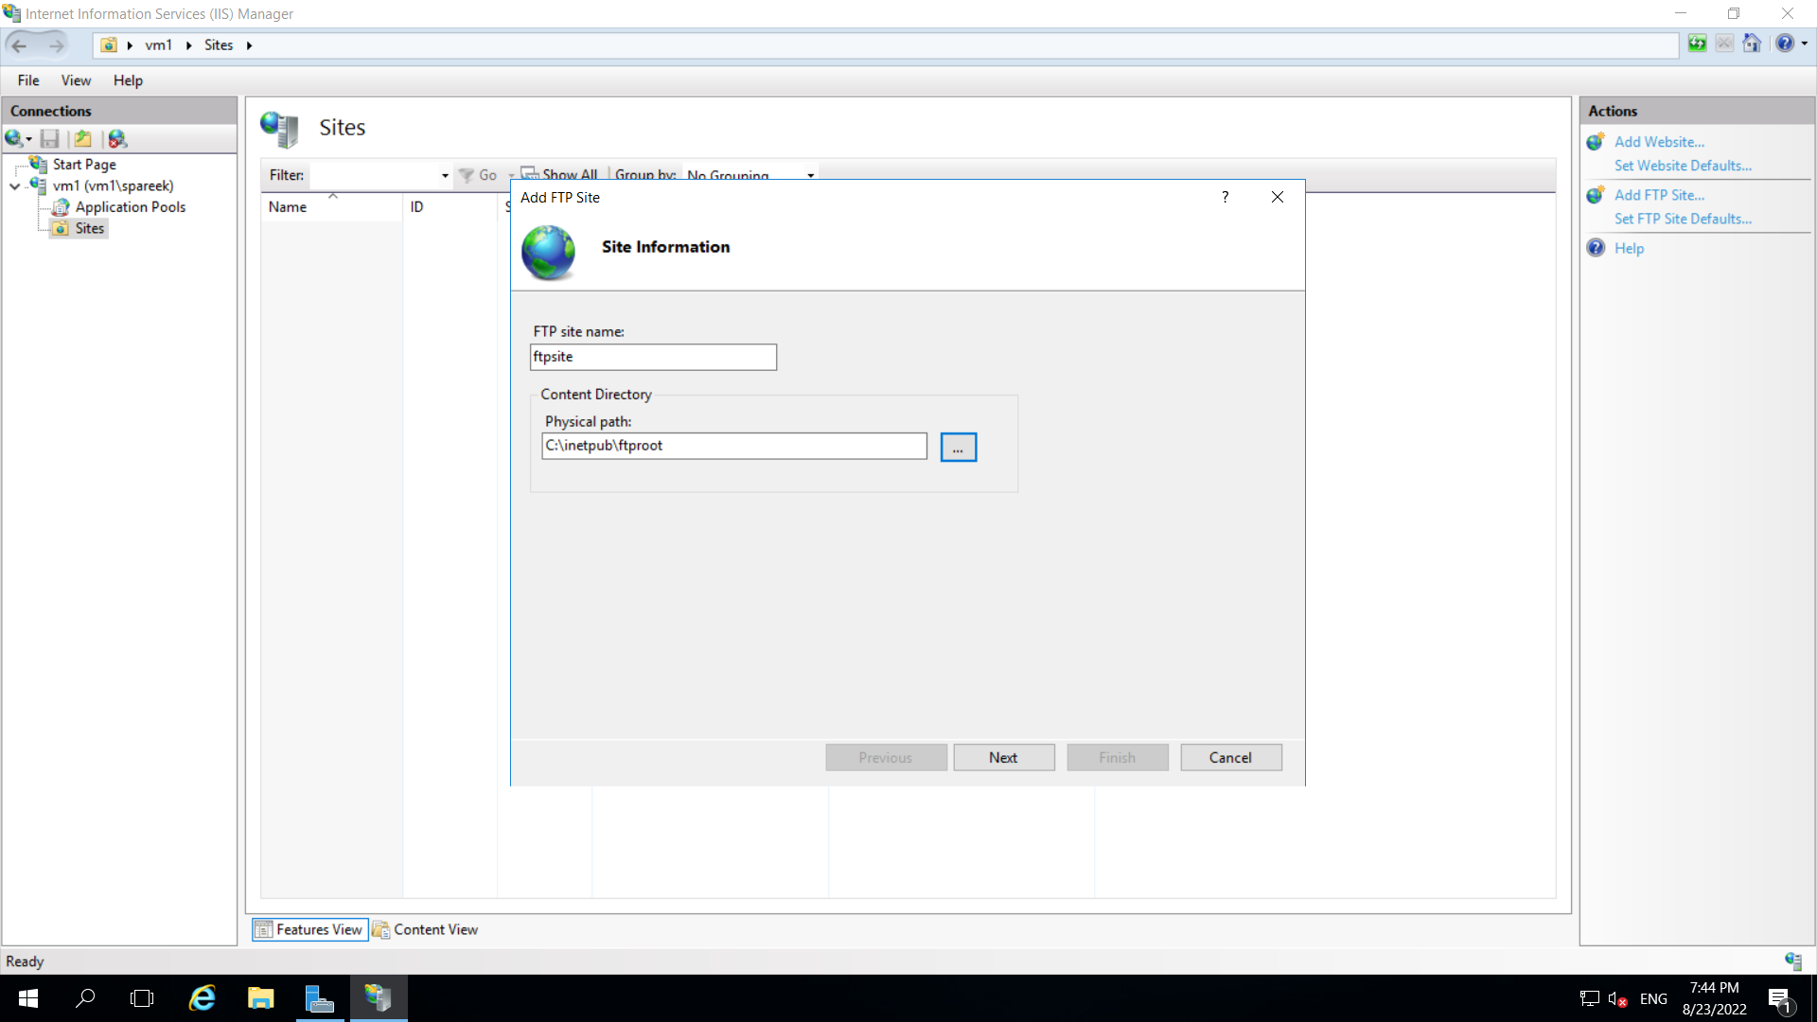

Step 5: Enter details of FTP firewall support.

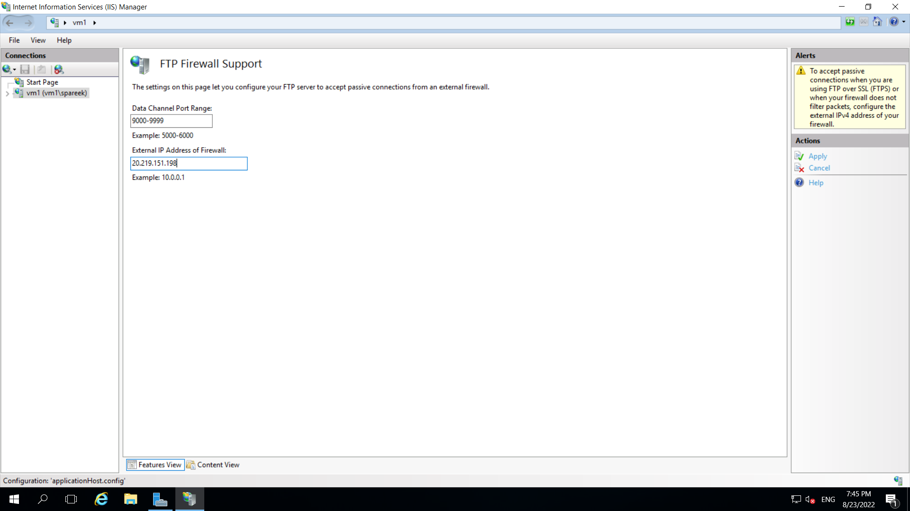

Step 6: Now inside Networking of vm1 add inbound port rules for FTP.

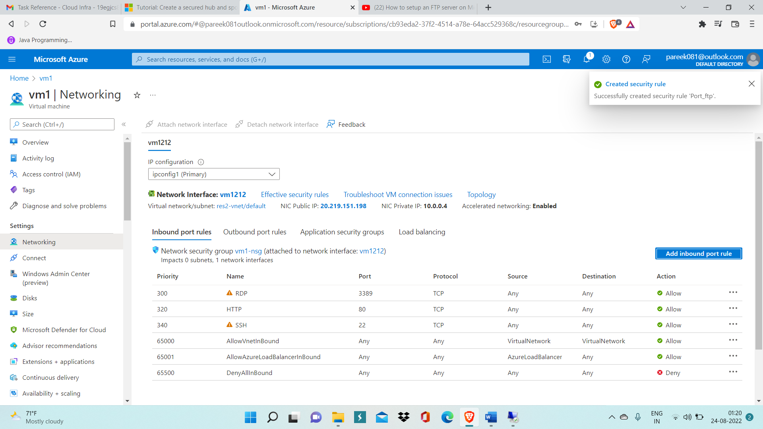

Step 7: Create a logic app now with name ‘logicappdemo-sp’.

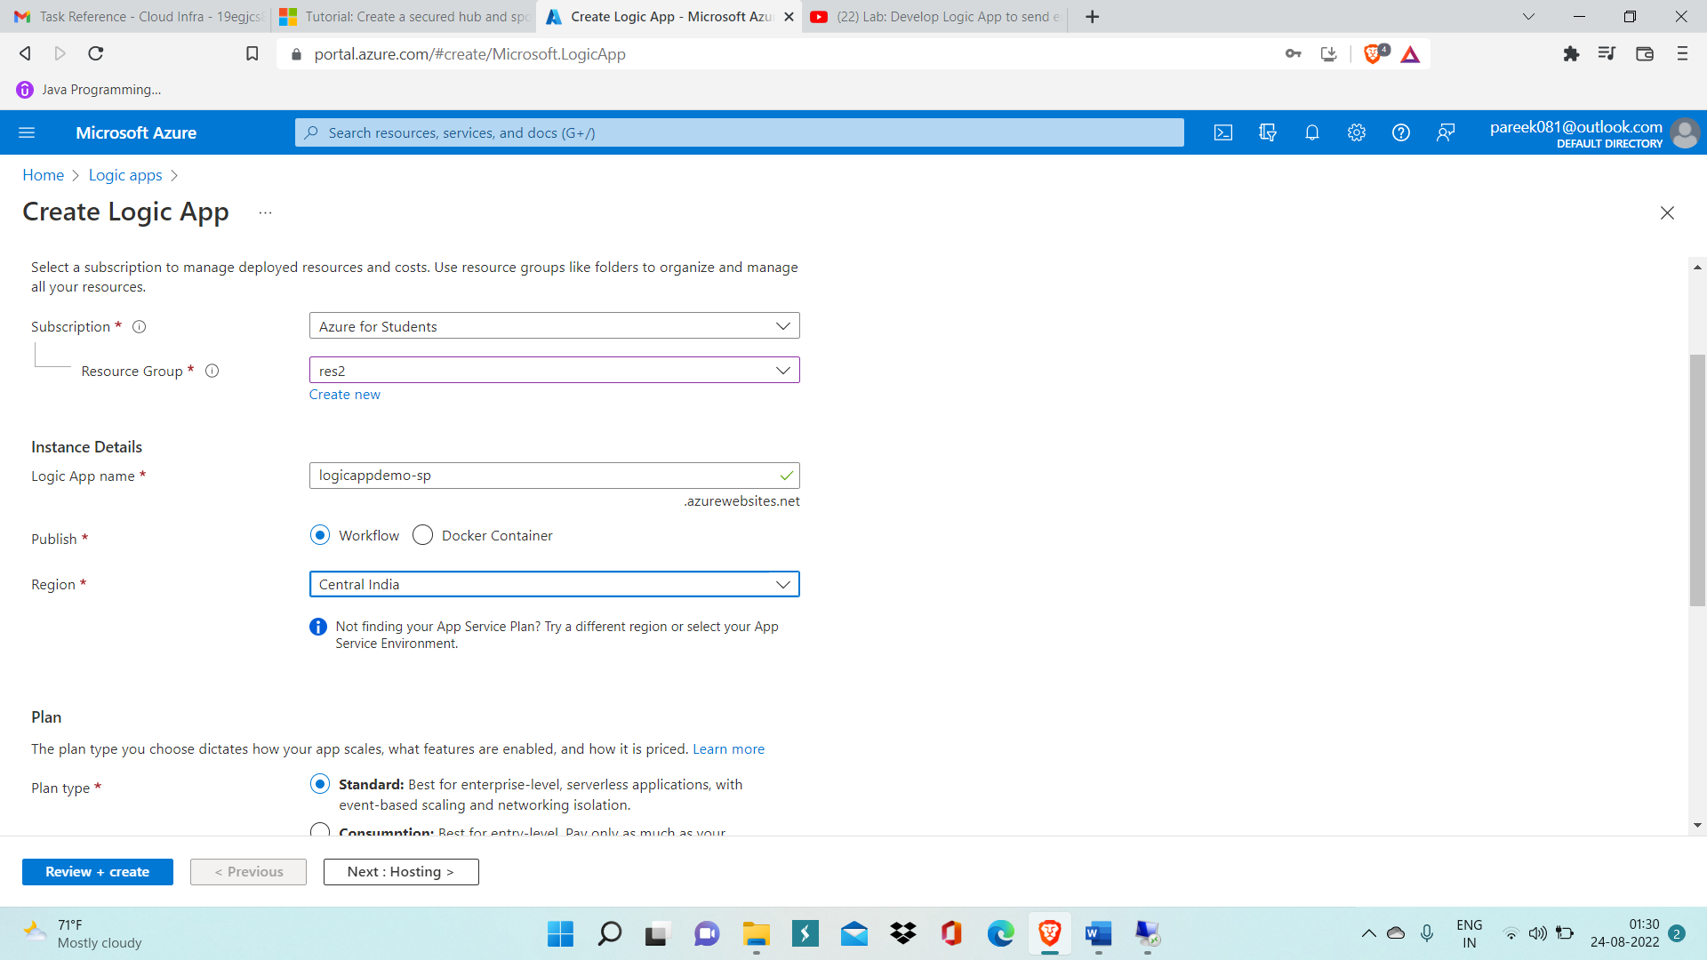

Step 8: Inside this logic app create workflow with name ‘demo-trigger’

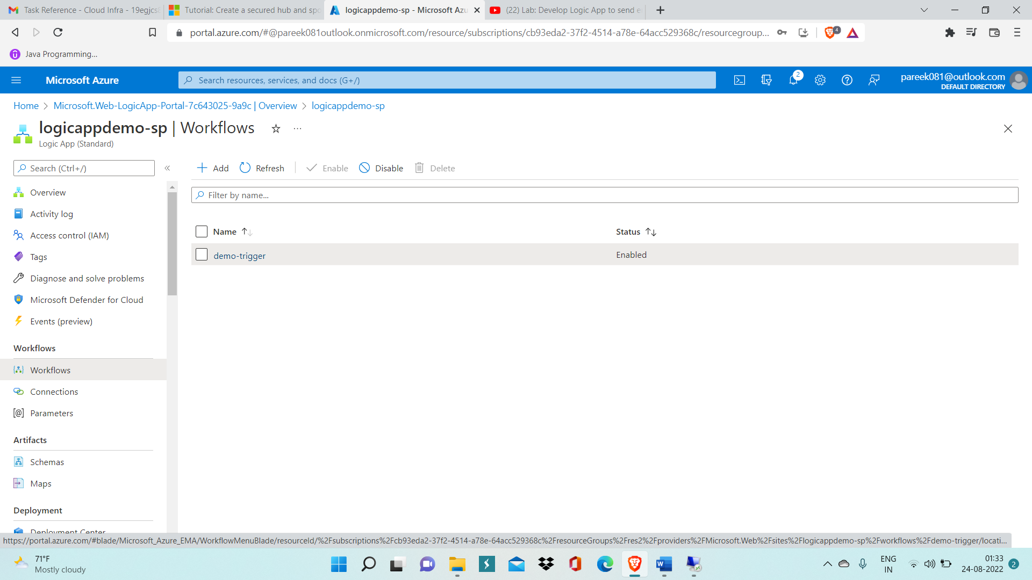

Step 9: Click on demo-trigger worklow and click on Designer.

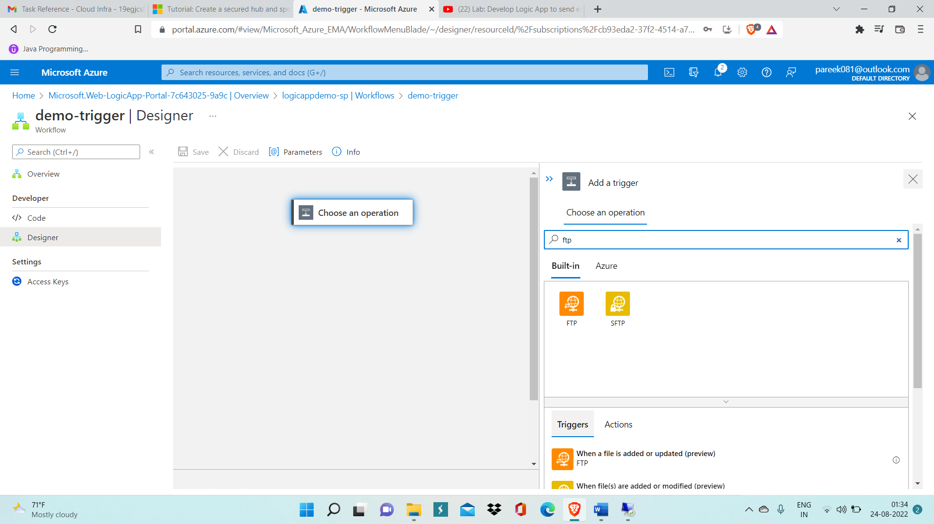

Step 10: Now select operation FTP and provide details like port number ftp server address etc.

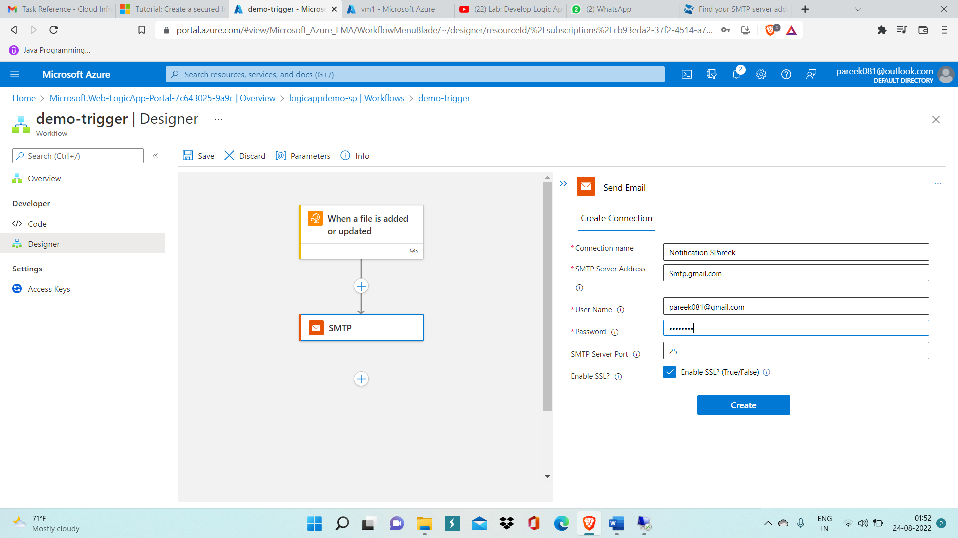

Step 11: Now click on Add an Action and choose SMTP.

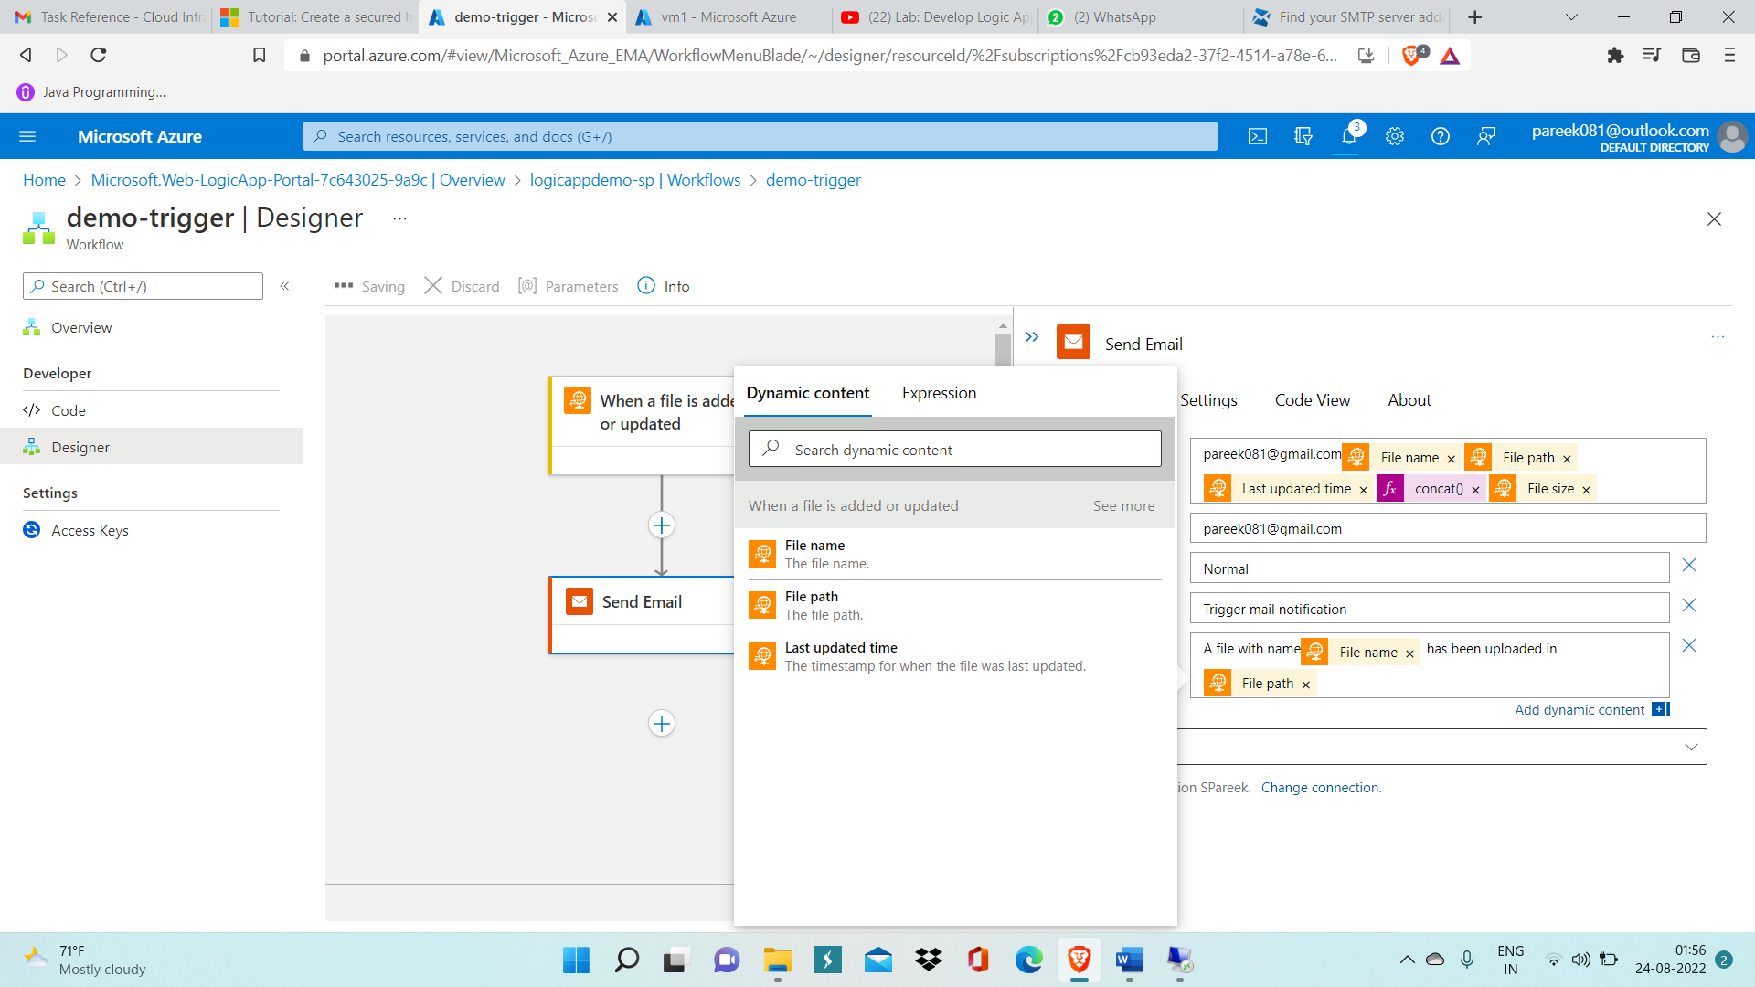

Step 12: In Send Email operation, provide all details like what all details you want to get attached in email you receive for every update on FTP server as shown in above image.

After this click on Save.

Step 13: Run Trigger now.

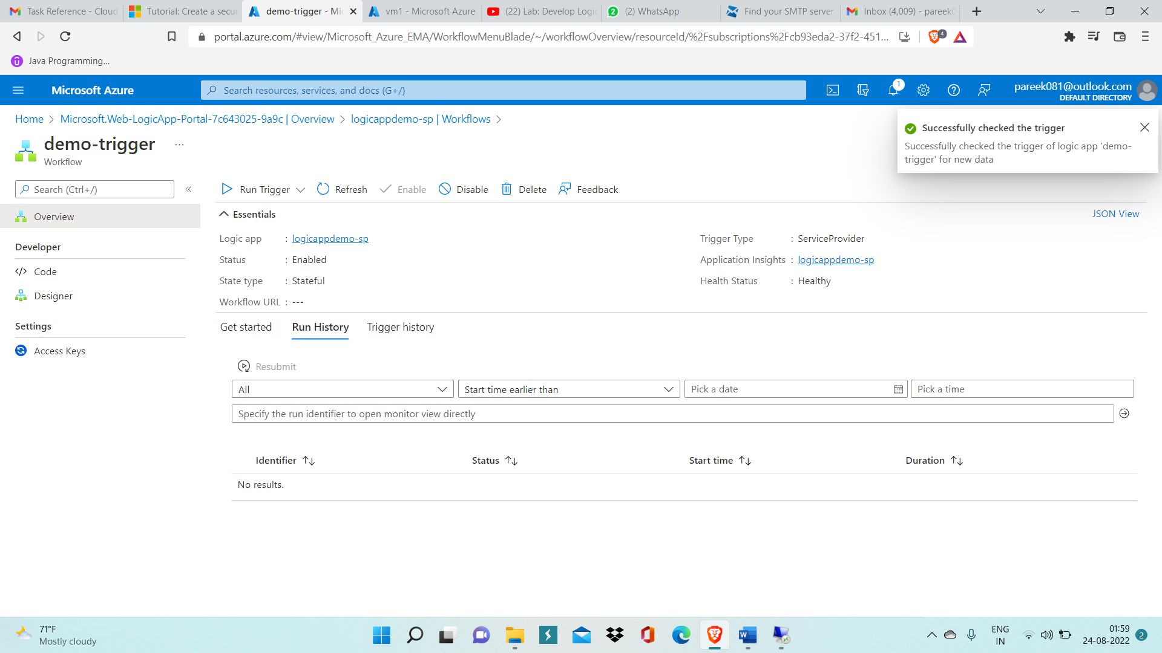

Note: Here SMTP interface is asking for work ID and the work ID I have starts with number and here the condition is that the your work ID(outlook account) should not start with number.

Therefore, we can’t proceed further.